Flow diagram of DVM:

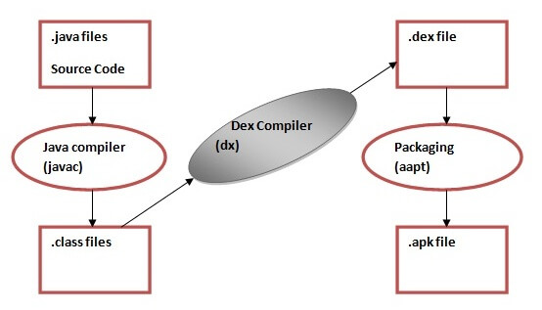

The **Dalvik Virtual Machine (DVM)** is an android virtual machine optimized for mobile devices. It optimizes the virtual machine for memory, battery life and performance. The Dex compiler converts the class files into the .dex file that run on the Dalvik VM. Multiple class files are converted into one dex file. One of the main reasons of using DVM in android is because it follows the register based model and it is much faster than stack based model while JVM follows the stack based model which takes a lot of memory and also slower than DVM.

Q2 importance of .java and .xml files

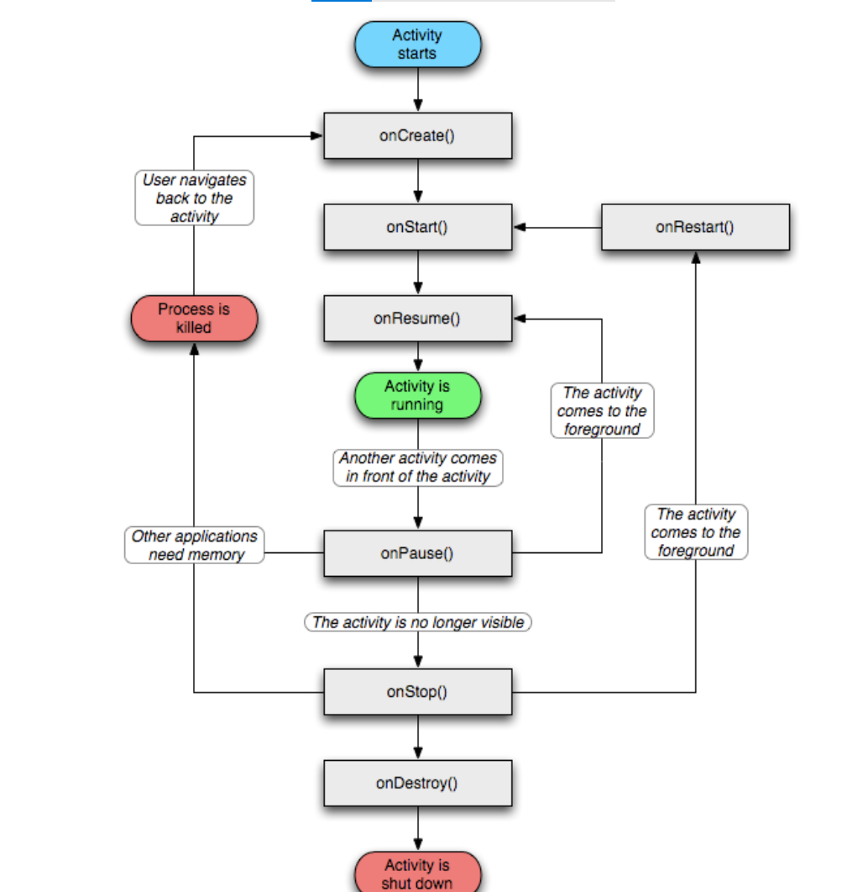

What is fragments in Android with example?

Android Fragment is the part of activity, it is also known as sub-activity. There can be more than one fragment in an activity. Fragments represent multiple screen inside one activity.

Service

Service is a background process that can run for a long time.

There are two types of services local and remote.

Local service is accessed from within the application

Remote service is accessed remotely from other applications running on the same device.

Let's see the example of service in android that plays an audio in the background. Audio will not be stopped even if you switch to another activity. To stop the audio, you need to stop the service.

Activity

An activity is a class that represents a single screen. It is like a Frame in AWT.

Intent

Intent is used to invoke components. It is mainly used to:

Start the service

Launch an activity

Display a web page

Display a list of contacts

Broadcast a message

Dial a phone call etc.

For example, you may write the following code to view the webpage.

Intent intent=new Intent(Intent.ACTION_VIEW);

intent.setData(Uri.parse("http://www.javatpoint.com"));

startActivity(intent);

Broadcast receiver

A broadcast receiver (receiver) is an Android component which allows you to register for system or application events.

For example, applications can also initiate broadcasts to let other applications know that some data has been downloaded to the device and is available for them to use, so this is broadcast receiver who will intercept this communication and will initiate appropriate action.

**Andriod Architecture:**

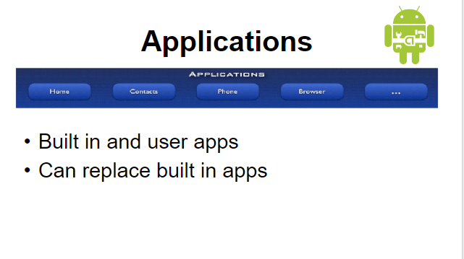

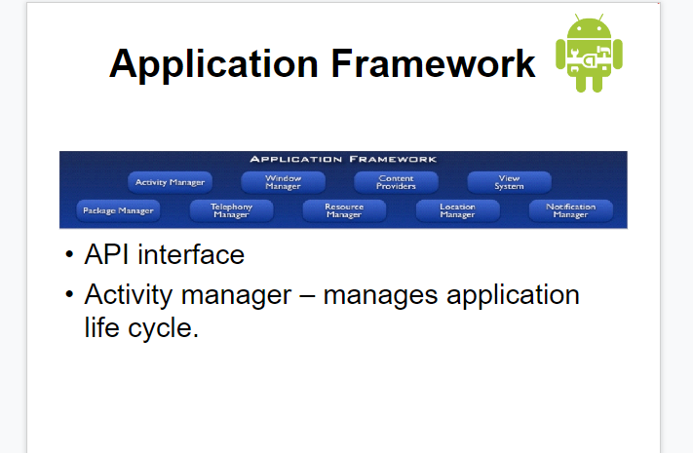

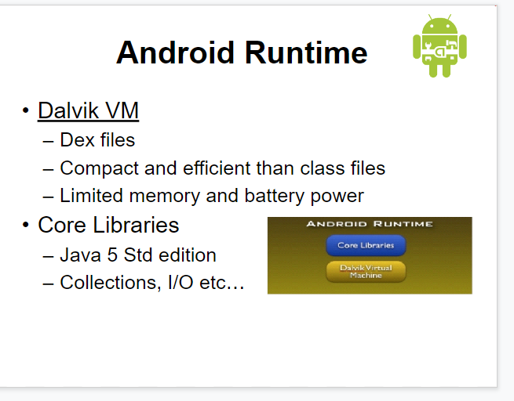

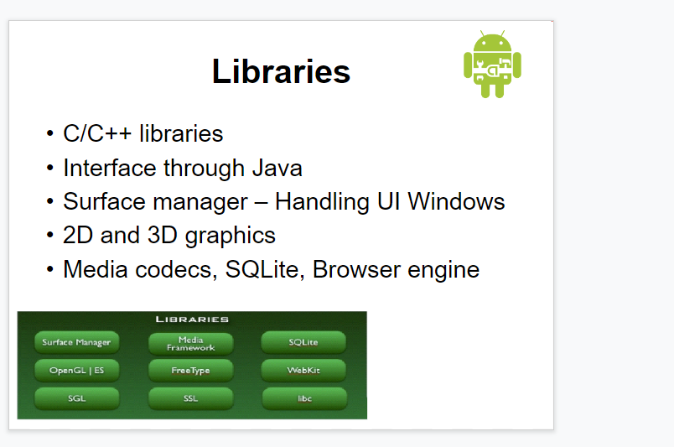

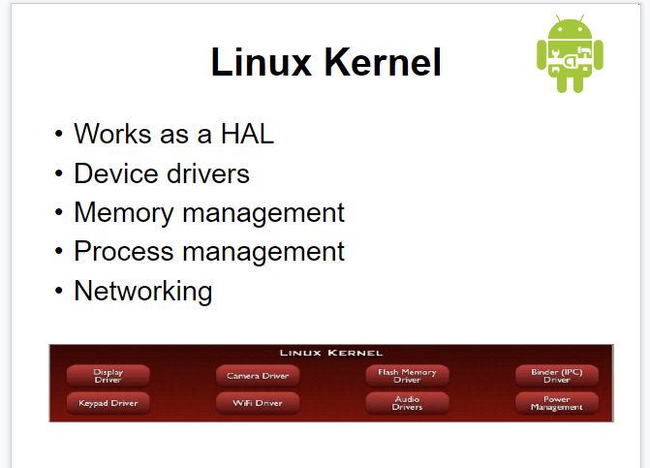

The AndroidManifest.xml file contains information of your package, including components of the application such as activities, services, broadcast receivers, content providers etc.

It performs some other tasks also:

It is responsible to protect the application to access any protected parts by providing the permissions.

It also declares the android api that the application is going to use.

It lists the instrumentation classes. The instrumentation classes provides profiling and other information. These information are removed just before the application is published etc.